Exp:7- Reproducing an Image Using Prompts for Image Generation
Aim:
To demonstrate the ability of text-to-image generation tools to reproduce an existing image by crafting precise prompts.
Objective:
To identify key elements within a reference image and use prompt engineering techniques to generate an image as close as possible to the original image using AI image generation tools.
Experiment: Learners must:
Analyze the provided reference image. Reference Image:- https://www.wechasethecolor.com/wp-content/uploads/2025/04/butterfly-coloring-pages.png
https://images.template.net/292657/Product-Launch-Poster-Template-edit-online.jpg
Identify important visual elements such as:
i)Objects/Subject ii)Background iii)Lighting iv)Style v)Color combinations vi)Camera Quality Create prompts for image generation tools. Generate refined outputs using prompt engineering techniques. Compare generated images with the original image.
AI tools that can be used: ChatGPT Image Generation Gemini Bing Image Creator Leonardo AI Canva AI Midjourney
Algorithm: Step 1: Select the Reference Image Choose or use the provided image for reproduction. Step 2: Analyze the Image Identify major components and visual details. Step 3: Create Initial Prompt Write a basic text-to-image prompt. Step 4: Generate Initial Output Use AI image generation tool to generate the image. Step 5: Refine the Prompt Improve the prompt using detailed descriptions. Add style, lighting, texture, and composition details. Step 6: Generate Final Output Produce improved image output. Step 7: Compare the Results Compare original and generated images. Document differences and improvements.
Output: 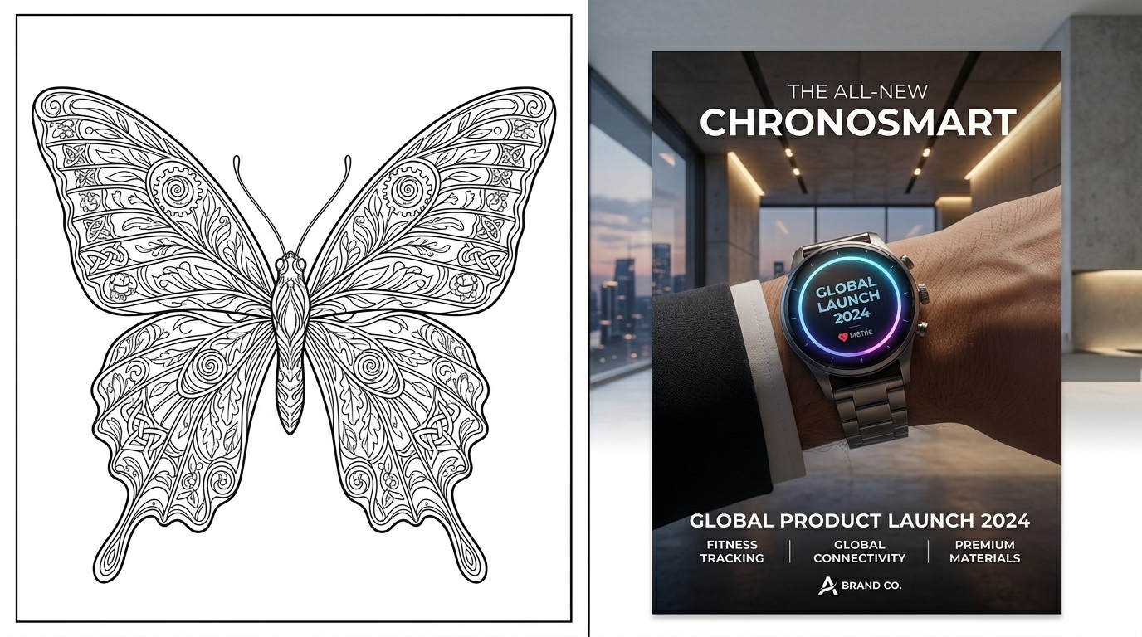
Result: Thus, the original image was successfully reproduced using prompt engineering techniques and AI image generation tools.

